Name: Omika Dharamdasani

Student Number: 1000984483

Lecture: 5101

Date: May 25, 2016

STA302 ASSIGNMENT 1

PART A

2a. Cleveland Browns had the most draft picks this year. They had 11 picks this year.

2b. Florida State had the most players drafted. 11 players were drafted.

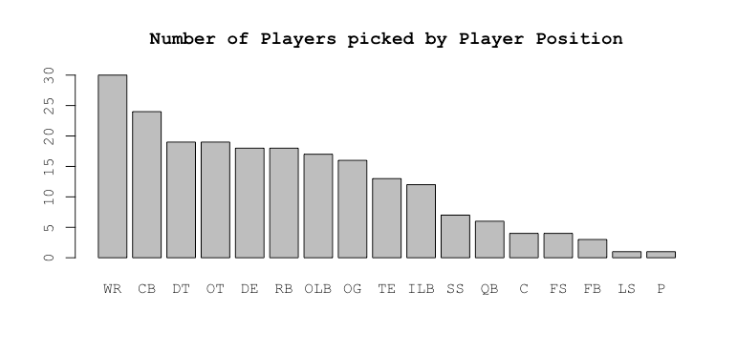2c.

2d.

Min. 1st Qu. Median Mean 3rd Qu. Max.

61.20 72.00 74.40 73.48 76.80 81.60

The average height for an NFL draftee this year is 73.48 inches.

2e.

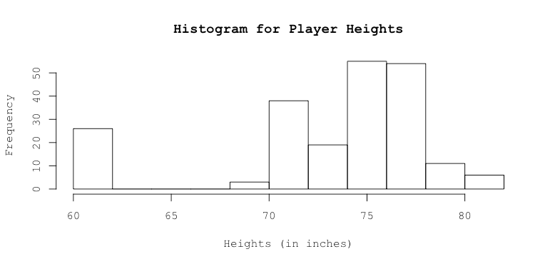

2f. The shortest players are Phillip Dorsett, D’Joun Smith, Tyler Lockett, Steven Nelson, Justin Hardy, Doran Grant, J.J. Nelson, Lorenzo Doss, Cameron Artis-Payne, Kyshoen Jarrett, Kaelin Clay, Charles Gaines and Derron Smith (13 in number). They are all 61.20 inches tall.

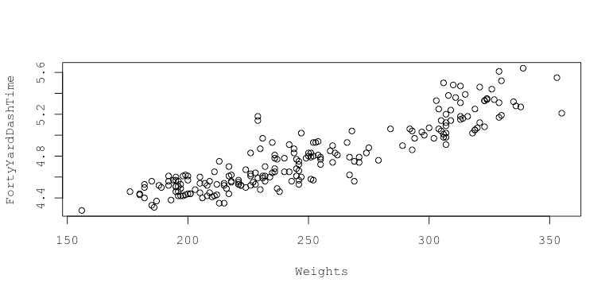2g.

Yes, the relationship looks linear. One thing that is unique to the outliers in this plot is that there are no overlapping points. They are few in number and are scattered horizontally instead of vertically, i.e. they are located to the left and right side of the data points.

2h. Yes, a positive linear relationship is present.

2i.

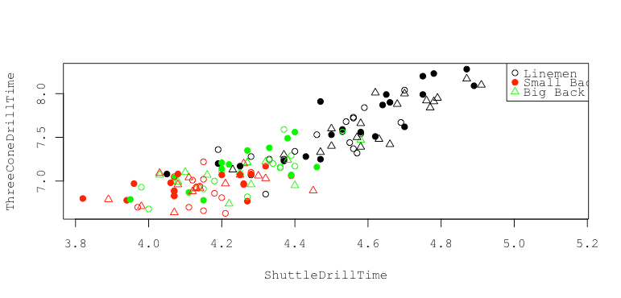

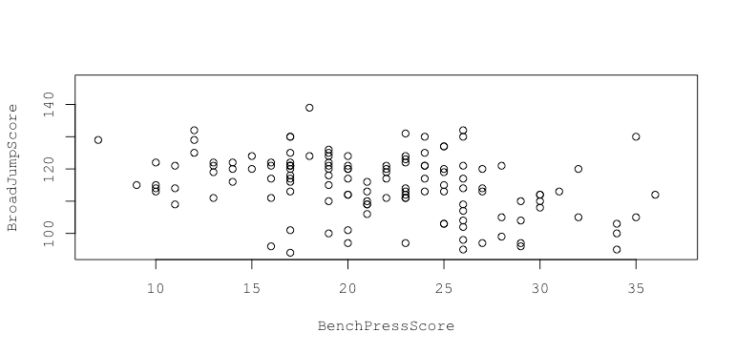2j.

No, the two test scores seem unrelated. When one variable changes, the other remains unaffected.

2k. Robert Myers and Austin Shepherd both have the shortest broad jump score of 94. Since Austin Shepherd is the lighter player with a weight of 315, while Myers has a weight of 326, we pick Austin Shepherd to have the shortest broad jump score. He was drafted in the 7th round.

2l. Byron Jones had the longest broad jump score of 147. His bench press rep number is not available.

PART B

1a. The estimated regression equation is:

Cone3 = 1.4530307\*Shuttle + 0.9509769

1b. We expect to get 0.951 seconds 3-cone drill time on average and 1.45 additional seconds of 3-cone drill time for each shuttle drill on average, where 0.951 is the intercept and 1.45 is the slope. As the p-value is less than 0.05, we conclude that there is a significant relationship between Cone3 and Shuttle. The p-value is less than 2.2e-16.

1c.

4 % 96 %

(Intercept) 0.4672872 1.434667

Shuttle 1.3417969 1.564264

1d. 95% confidence interval for all players with shuttle time = 4.5s

fit lower bound upper bound

1 7.489615 7.453684 7.525546

1e. 95% prediction interval for a new player with shuttle time = 4.7s

fit lower bound upper bound

1 7.780221 7.415916 8.144527

2. It is certainly reasonable to model draft ranks as a function of the 40-yard dash times, since speed is essential in football. However, this may not be the best measure. Since correlation predicts the robustness of a relationship, I calculated the correlation of draft picks with every other test score. The correlation of 40-yard dash times with draft picks (0.08) was lower than some of the others that I calculated. The highest positive correlation that I observed was of Shuttle Drill times (0.134), and in the negative direction, the relationship between vertical jump scores and draft picks was the strongest (-0.232). This suggests that these two test scores might be better choices than the 40-yard dash times.